# Utilisation de IRremote

Télécommande Télé Strong

1 -> AC535FA0

2 -> AF505FA0

3 -> ED125FA0

4 -> B04F5FA0

5 -> B34C5FA0

6 -> F10E5FA0

7 -> B44B5FA0

8 -> B7485FA0

9 -> F50A5FA0

0 -> BB445FA0

Vol + -> BF405FA0

Vol - -> A25D5FA0

Ch + -> FC035FA0

Ch - -> E01F5FA0



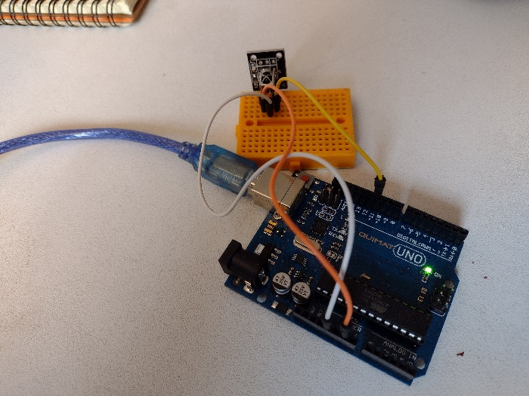 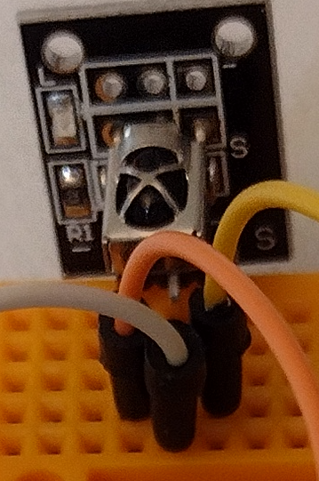

data

gnd

vcc

#include <IRremote.hpp>

int IR_RECEIVE_PIN = 11;

void setup()

{

Serial.begin(9600);

IrReceiver.begin(IR_RECEIVE_PIN, ENABLE_LED_FEEDBACK); // Start the receiver

}

void loop() {

if (IrReceiver.decode()) {

Serial.println(IrReceiver.decodedIRData.decodedRawData, HEX);

// IrReceiver.printIRResultShort(&Serial); // optional use new print version

IrReceiver.resume(); // Enable receiving of the next value

}

delay(100);

}